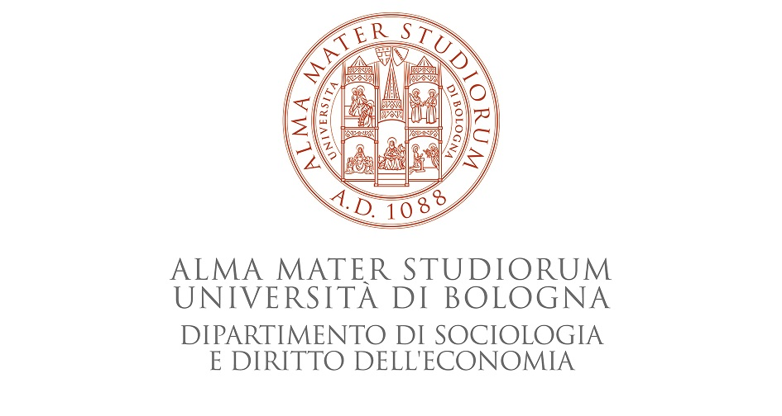

INTERNATIONAL SYMPOSIUM

Beyond Humanitarian Narratives: Critical Perspectives
on Media, Migration, and International Cooperation

20 – 21 March, 2013 - Sala Poeti, Palazzo Hercolani
Strada Maggiore 45, Bologna - Italy

Wednesday, March 20 - Sala Poeti

14.15 - 15.00 | Arrivals and Registrations

Ore 15.00 | Greetings
Ivano Dionigi, Rector, University of Bologna
Giovanni Pieretti, Director, Dipartimento di Sociologia e Diritto dell’Economia
Matteo Lepore, Deputy Mayor for International Relations and Urban marketing, City of Bologna
Fabio Laurenzi, President, Cospe

15.30 | I Session –Humanitarian Communication: ethic and political aspects

Introduction and chair: Paola Parmiggiani (University of Bologna)

Keynote Speaker:
Suzanne Franks, City University of London, UK
Missing out on the politics - Media coverage of humanitarian crises.

16.30 | Discussants:
Fausto Colombo, Cattolica University of Milano
Pierlugi Musarò, University of Bologna

17.00 | Questions and Answers

17.30 | break

17.45 | Film screening and discussion with director

Documentary Film Niguri, by Antonio Martino

Introduced by: Giulia Grassilli, Director of Human Rights Film Festival

Thursday, March 21 - Sala Poeti

8.45 - 9.15 | Arrivals and Registrations

9.15 | II Session – Media Production I

Chair: Giovanni Boccia Artieri, University of Urbino “Carlo Bo”

speakers:
D. De Felice, S. Fragapane, G. Giuffrida, Università di Catania
Media representation of the unaccompanied foreign child: an analysis on online newspapers
Karina Horsti, University of Jyväskylä, Finland
Intersections in victimization: Gender, age, religion, race and ethnicity in mediated pro-asylum activism
Francesco Pira, Università di Messina
Migration and Media: a survey of the phenomenon of social perception from traditional medias to social networks.
Andrea Pogliano, Università del Piemonte Orientale “A. Avogadro”
The burden of the humanitarian representation. Media frames and public opinion on migrants and immigration

Ore 11.00 | Coffe break

Ore 11.15 | II Session – Migrants’ voices: discourses on migration

Chair: Sandro Mezzadra, University of Bologna

speakers:
Marco Bruno, Sapienza Università di Roma
A different voice of immigrants in Italian news-media? Beyond the construction of social alarm, the claim for the rights: media images of immigrants’ revolt in Brescia
Giacomo Solano, Università di Milano Bicocca
From ‘extracomunitario’ to ‘clandestino’: the immigrant in the media discourse
Kaarina Nikunen, University of Tampere, Finland
Hopes of Hospitality: Media, Immigration and the Politics of a Place
Selenia Marabello, Università di Bergamo
The migration who produces: discoursive reverse shots on migration and development.

Ore 13.00-14,30 | Lunch break

Ore 14.30 | III Session – Humanitarian emergency and border control

Chair: Pierluigi Musarò, University of Bologna

speakers:
Valentina Bartolucci, Università di Pisa/University of Bradford, UK
The migrants’ invasion: Symbolic construction of a humanitarian emergency in the Italian policy discourse in the aftermath of the Arab uprisings
Emanuela Dal Zotto, Università Statale di Milano
The recourse to the category of emergency for the representation and the management of forced
migrations
Maria Gabrielsen Jumbert, Peace Research Institute Oslo (PRIO)
Whose security in the Mediterranean? Contrasting Border Control and Humanitarian Narratives and Representations of Migrants at Sea
Mika Aaltola, Tallinn University, Estonia
Violence of Global Flows: Portraying and Policing Human Mobility from West Africa to Europe

Ore 16.15 | Coffe break

Ore 16.30 | IV Session – Media Production II

Chair: Piergiorgio Degli Esposti, Universiy of Bologna

speakers:
Emily Bauman, New York University
Jump Cut to Development: Internal Migration Narratives in the PRC
Giuseppina Bonerba, Università di Perugia
The Humanitarian Narrative In Cinema: Examples And Issues

Sara Saleri, Università degli studi di Bologna
The story of a crane. A contended discursive space
Antonia Cava, Università di Messina
Migrants as shadows. Discourses on foreigner

per info: Pierluigi Musarò – Università di Bologna pierluigi.musaro@unibo.it

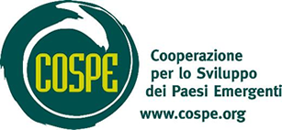

Thursday, March 21 - Aula Dipartimento Sociologia e Diritto dell’Economia

Ore 14.30-18.00 | Workshop on Media and Social Communication*
(N.B. the workshop will be held in Italian)

Chair: Lella Mazzoli, Università di Urbino “Carlo Bo”
Moderatore: Jonathan Ferramola, Cospe

Relazioni di apertura:

Giovanni Egidio, Caporedattore La Repubblica Bologna

Anna Meli, Cospe e Associazione Carta di Roma

Claudia Santoni, Università degli Studi di Macerata

Marco Carniani, Barbara Andreani, Ondemigranti

Lucia Manassi, Radio Città del Capo Bologna

Viorica Nechifor, ANSI - Associazione Nazionale Stampa Interculturale

SEGUE Dibattito

Ore 20.00 | Live Performance and Dinner
Scuola di cucina del mondo AMITIE - cucina dal Senegal con Chef Abdoulaye Gaye, in occasione della giornata mondiale contro il razzismo. Percussioni africane, Dj set AfricanBamba.
@ La Gazzetta, Via Zamboni 22 (in Piazza Verdi, angolo Largo Respighi)
* Per la partecipazione al workshop è necessario inviare la propria iscrizione inviando una mail a francesca.cospe.bo@gmail.com

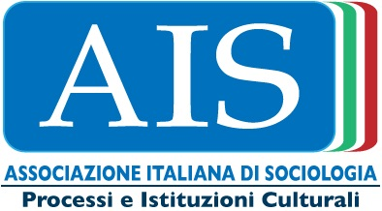
Con il patrocinio di


This programme is funded by the European Commission. The views expressed do not necessarily reflect the views of the European Commission

